Hosted Telephone system

Basic User Guide for Yealink Telephones

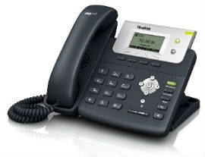 | 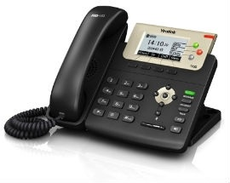 | 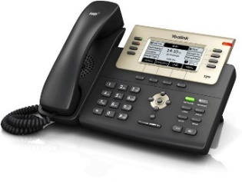
T21 | T23 | T27
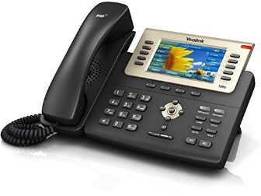 | 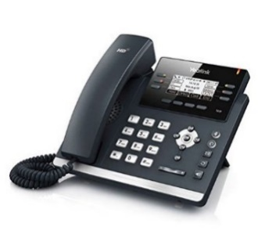 | 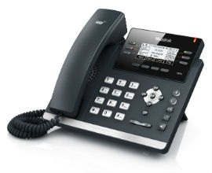
T29 | T41 | T42
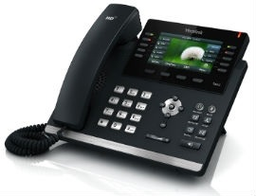 | 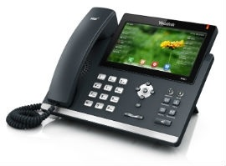 | 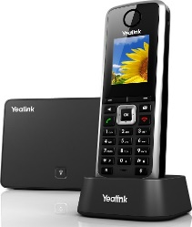
T46 | T48 (touch-screen) | W52 (cordless)

Contents
About this guide 3
System overview 3
Making Calls 3
Handling multiple incoming calls 3
Transfering a Call 4
Desk-phones with a dedicated “Transfer” button 4
Cordless phones 4
Diverting calls on your extension to another number 5
Option 1: Call forwarding via the switchboard 5
Option 2: Call forwarding on your phone 6
Voicemail Management 6
Managing personal voicemail greetings and messages 6
Managing Group Voicemail Boxes 7
Conference calling 7
pick up a call on another ringing phone 7
Advanced Features 8
System Control Codes 9
system Codes for System Administrators only 10

About this guide
This basic user guide explains how to do routine operations on your telephone system such as transferring calls, managing voicemail and arranging simple conference calls. If you wish to learn how to set up the more advanced features of the system then we can supply you with a comprehensive system administration manual. You are also welcome to ask our technical support team for advice and practical assistance with any features and options. Telephone support is always free of charge.

This guide does not describe of all features of your telephone handsets. If you need information about a specific feature of your Yealink telephones then please consult the separate manual for your model of phone or contact us. You can download handset user manuals from http://partners.vipvoip.co.uk

Telephone System overview
Your system consists of a set of telephones which are connected to a centrally-hosted office switchboard via the internet. Each telephone in your organisation is assigned a unique extension number. The switchboard system runs special software which control the way internal and external calls are handled. The system has a comprehensive set of built-in features which include:

- Unlimited telephone numbers with any area codes you like.
- Transfer calls between extensions and to external numbers.
- Call Groups
- Hunting sequences
- Auto-forwarding to mobiles
- Out-of-hours call handling
- Auto-attendants
- Call queue manager
- Conferencing
- Message players – for greetings
- Music-on-hold or message-on-hold
- Personal voicemail and work-group voicemail boxes – with email alert
- Call recording
- Whisper messages
- Blacklists to block nuisance calls
- Listen-in to calls – for training
- Hot desking
- Call encryption
- Click-to-dial from computer applications
- Call logger
- Wallboard displays for real-time call monitoring
- Bespoke management reports

Making Calls
Either pick up the handset or press the “speaker” button then dial the number on the keypad and press the Call key.
On desk-phones the Call key is the OK button in the middle of the silver navigation pad.
On cordless phones the Call key is the button with a green telephone icon

If your telephone has speed dial buttons then make calls simply by pressing one of the buttons.

To call an international number please dial 00 before the country code. Your telephones will only be able to make calls to international numbers if your System Administrator has authorised us to activate the feature on your extension. The feature is disabled by default.

On request we can also bar all external calls on specified extensions and we can bar calls to expensive “special service numbers” with 084 and 087 prefixes.

You cannot make calls to premium rate (09xx) numbers under any circumstances.

Using the built-in directory
The telephone has a built-in directory where you can create contact entries with their names and phone numbers. Please consult the user guide for your particular model of telephone for detailed instructions on how to create and search for directory entries. The procedure varies between models.

The hosted telephone switchboard also has a feature to maintain a company-wide directory of contact names & numbers which is then propagated automatically to each telephone. The shareable directory feature must be enabled by your Solution Provider and it requires some changes to the configuration of your telephones. Please contact your Solution Provider if you would like to set up this feature.

When you have created entries in the built-in directory then you can open the directory menu on the telephone and search for the contact name just as you would on a mobile phone. When you have found the correct entry then press the Call key.

When you receive a call from someone who is named in the directory then their name will be displayed on the telephone screen instead of their telephone numer.

Handling multiple incoming calls
All phones models have a “call waiting” feature which alerts you with an audible signal when a new call comes in while you are already engaged on another call. Desktop phones also let you put a caller on hold while you respond to a second incoming call. The process of dealing with this situation is explained below.

While you are in conversation with Caller A you receive a call from Caller B. You will hear a beep-beep tone to indicate that a call is waiting and you will see the ID of the second caller on the telephone screen. If you wish to respond to Caller B then:

- Advise Caller A that you are going to put them on hold for a few seconds
- Press the CALL button to answer Caller B (Caller A goes on hold automatically and hears music)

If you wish to return to Caller A while keeping Caller B on the line then:

- Press the “up” arrow on the central navigation button to return to call 1 (Caller B is now put on hold)
- You will see the word “Hold” appear on the screen which tells you that Caller A is on hold
- Press HOLD button to toggle off hold and you will be speaking to Caller A again.
- Press the down arrow to go back to Call 2
- Press HOLD button to toggle off hold and speak to Caller B again.

Transfering a Call
There are two ways to transfer a call to another extension:
- Unannounced (simple) transfer where you simply pass the call over to the other person’s line and your line is hung-up.
- Announced transfer where you can announce the caller and give the other person the chance to accept or reject the call

The procedure for each type of transfer operation depends on whether or not your phone has a dedicated “Transfer” button. Yealink desk phones have a button for this purpose which is marked TRAN. Cordless phones do not have a special transfer button. The procedure on these phones is described separately.

Desk-phones - with a “Transfer” button

Simple (blind) transfer procedure
- Inform the caller you are going to transfer them.
- Press the Transfer key. The caller will be put on hold, hearing music, and you will get a dial-tone.
- Dial the target extension number or an external telephone number and then press the OK button.
- You then hang up.

Announced transfer procedure
- Inform the caller you are going to transfer them.
- Press the Transfer key. The caller will be put on hold, hearing music, and you will get a dial-tone.
- Dial the target extension number or an external telephone number and then press the OK button then wait for the person to answer.
- When the person answers, announce the caller. If they want to take the call then press the Transfer button again and hang up.
- If there is no answer from the target extension or if they cannot take the call then press the UP arrow on the silver navigation button and you will see a resume option appear on the screen. Press the corresponding button below Resume and you can speak to the original caller again.

Cordless phones – without a “Transfer” button

Simple (blind) transfer procedure:
- Inform the caller that you are about to transfer them.
- Key ## and the caller will be put on-hold and you will hear the system speak the word: "Transfer".
- Dial the target extension or external telephone number. .
- As soon as the call connects, hang-up by pressing end “end call” button and the call will be transferred.

Announced transfer procedure:
- Inform the caller that you are about to transfer them.
- Key: ## and the caller will be put on-hold and you will hear the system speak the word: "Transfer".
- Dial the target extension or external telephone number and wait for it to answer.
- When the person answers, announce the caller. If they want to take the call then just hang up by pressing the “end call” button.
- If they do not want to take the call or if there is no answer then key #0 to speak to the original caller again.

Diverting calls on your extension to another number
There are three alternative strategies for diverting calls to alternative numbers (either other internal extensions or external landlines or mobiles). The three main options are:

- Dial a command code on your phone which instructs the switchboard server to divert calls to an alternative number. This will remain in operation until you dial a “switch off” command. This method will forward calls which were destined for your specific extension only. It will not apply to calls which reach your phone as part of a hunting sequence or as a part of Call Group.

- Use the menu on your telephone to set the telephone unit into call-forward mode. All calls to your telephone will then be redirected to the target number until you turn off call forwarding. This method only works when your phone is switched on and connected to the internet.

- Set up an automated call handling strategy for your extension using the switchboard software control panel. This can be used to redirect calls to an alternative number at specific times on specific days or in situations where your extension is offline. We do not expect (or advise) users to do this themselves. Your Solution Provider will set this up for you free of charge upon request.

Option 1: Call forwarding via the switchboard

The following codes allow you to divert your extension temporarily to another number. The number may be an internal extension or if you have sufficient privileges to an external number. Diverts may be set in three ways:

- Divert all calls.
- Divert when you are busy on the phone.
- Divert if you don't reply within a certain time.

Divert on “no reply” activates after a period of time which you can specify. If an inbound call is not answered within that time then the call is diverted to the pre-set internal or external number. The default timeout period is 20 seconds. You can change this by using code *48 (see below).

Use the following codes to set or unset the call forwarding features:

*42number Sets divert all to a target number
*42 Clears divert all

*43number Sets divert on busy to a given number
*43 Clears divert on busy

*44number Sets divert on no reply to a given number
*44 Clears divert on no-reply.
*48seconds Set the no-reply timeout to the number of seconds supplied.
*48 Reset the no-reply timeout to the default value (20 seconds)

*40 Clears all diverts to other numbers including Follow Me and Do Not Disturb.

Option 2: Call forwarding on your phone

This procedure only works on Yealink desk phones.

- Press the Menu button on the phone
- Navigate to the call forwarding menu (the procedure varies between telephone models)
- Select either Always to have all calls forwarded, ‘Busy’ for calls to be forwarded when the phone is engaged or select ‘No answer’ so if nobody picks up the phone then the call will be forwarded.
- Once you’ve selected the appropriate option use the arrow keys to choose enable or disable and then press OK.
- Press the down arrow to type the number you want to forward to in and then press OK.

Voicemail Management
The system uses a set of mailboxes for recording messages if calls cannot be answered. Each telephone extension has a built-in personal mailbox. You can set up any number of other mailboxes for different teams or for different telephone numbers.

Every mailbox is identified by an extension number. For individual users’ extensions the mailbox number is the same as the user’s extension number.

The system causes the “message” light to flash on specific phones to alert users that message have been left. The system can also be set to automatically generate an email to a predefined email address whenever a message is left in a mailbox. The email has an audio file attachment which contains the voice message. The recipient can play back the message on their computer or mobile device,

Important note

Messages will accumulate in each mailbox until someone listens to them on a phone and deletes them. Without routine management the mailboxes could fill up the point where they cannot accept any more messages.

We recommend that you have routine procedure to check each mailbox, maybe once a week, to listen to messages and delete them.

Managing personal voicemail greetings and messages

Each mailbox has the option to play two alternative personalised greetings to a caller. One greeting is referred to as the “unavailable” message. This is the default greeting which is played after a period of ringing if you are unavailable to take the call. The second greeting is referred to as the “Busy” message. This will be played if you are engaged (busy) on another call.

To set up your mailbox greetings or play back voice mail messages from your own extension you can either press the “msg” button on your phone or dial 901. The system will ask you for your mailbox number (which is your extension number) and ask for your password (which is also your extension number). It will then talk you through the options available.

The system allows you to set your personal extension to go to voicemail in one of three ways:

- Divert all calls to Voicemail
- Divert calls to Voicemail only when you are busy on the phone
- Divert calls to Voicemail only if you don't reply within a certain time.

The system codes to activate and deactivate these features are listed below.

*521 Sets Divert all calls to Voice Mail
*520 Clears divert all calls to Voice Mail.
.
*531 Diverts calls to voicemail if your phone is busy (engaged).
*530 Cancels diversion to voicemail if your phone is busy.

*541 Diverts calls to voicemail on “no reply” (if your phone isn't answered within a certain period of time). The default timeout period when a call will divert to voicemail is 20 seconds.

*540 Cancels divert of calls to voicemail on “no reply”.

*48secs Sets the timeout period to the defined number of seconds.
*48 Resets the “no reply” timeout to the default value.

*50 Clears all diverts to Voice Mail.

Please remember to press the CALL key after entering these code sequences.

Managing Group Voicemail Boxes

We usually set up at least one special mailbox to be the main company answering machine. This is normally set as extension 500. We might also have set up one or more additional group mailboxes for different purposes.

Each group mailbox can have two personalised greetings. One greeting is referred to as the “unavailable” message. This is the default greeting which is played after a period of ringing if nobody is available to take the call. The second greeting is referred to as the “Busy” message. This will be normally only be used as a part of an out-of-hours call handling strategy to play a message such as “I am sorry our office is closed, our opening hours are …. etc”.

To record personalised greetings and access messages in these group mailboxes:

- Dial 901
- Enter mailbox number followed by # key
- Enter password followed by # key (password is the same as the mailbox number)

Conference calling
Some models in the Yealink range have a special CONF button which enables three-way conference calls.

- Make a call in the normal way to the first person (internal or external)
- Press the CONF button on your phone
- Call the second person
- Press the CONF button again

You and the two other people will now be able to talk together. Please note that if you hang up then the three-way call will end.

The system also has an option (at extra cost) to use special conference rooms. These are used to host scheduled conference calls with an unlimited number of participants who can be internal or external.

Please contact Yestech for more information about this service.

pick up a call on another ringing phone
You can pick up a call which is ringing on any group of phones by dialling ** followed by the CALL button.

To pick up a call from a specific extension which is ringing then dial **nnn where nnn is the target extension number.

Advanced Features

The telephone switchboard software has many other sophisticated features for managing calls. These include:

Call Groups | Make groups of phones ring at the same time
Hunt Groups | Build a sequence of extensions to ring
Queues | Put multiple callers into a queue and announcing their positon
Auto attendant | Automated response to calls such as “press 1 for sales or press 2 for Accounts”
Direct Dial | Set up separate phone numbers for individual users or work-groups
Timetable control | Set up different call pathways for different days or times of the day
Conferencing | Enable any number of participants to join a conference call
Listen-in | Allow a supervisor to listen-in on a call
Call logging: | Analyse incoming and outgoing call statistics by extension
Call recording | Record conversations on specified extensions
Announcements | play greetings or announcements at different stages when calls are received
Music-on-hold | You can choose your preferred music track and will upload it. You can also replace music with an advertising message.
Ring tones | Play a different tone if the call is external or internal
Shared directory | Create a central directory of names and numbers for quicker dialling/

Please contact our help-desk if you would like advice any advice or assistance with using these features.

System Control Codes
Remember to press the “CALL” button your phone after entering a control code

*40 | Clears all diverts to other numbers including Follow Me and Do Not Disturb.
*42<number> | Sets divert for all calls to a given number
*42 | Clears divert
*43<number> | Sets extension diverting on busy to a given number
*43 | Clears diverting on busy to a given number.
*44<number> | Sets extension diverting on no reply to a given number
*44 | Clears diverting on no-reply.
*48 <number> | Set the no-reply timeout to the number of seconds supplied.
*48 | Reset the no-reply timeout to the default value (25 seconds).
*45 | Clears any Follow Me from this extension.
*45<number> | Sets Follow Me from the given extension to the one you are currently using.
*46<number> | Cancel Follow Me from the designated extension to this extension.
*491 | Turn on DND (do not disturb)
*490 | Turn off DND
*50 | Clear all diverts to Voice Mail
*520 | Clears divert all calls to Voice Mail.
*521 | Divert all calls to Voice Mail.
*530 | Cancels divert of calls to Voice Mail if your phone is in-use.
*531 | Divert calls to Voice Mail if your phone is in-use.
*540 | Cancels divert of calls to Voice Mail if no reply
*541 | Divert calls to Voice Mail if no reply
*60 | Play Music On Hold.
*64 | Speaking Clock.
901 | Access voicemail for any other extension
** | To pickup any ringing phone.
**nnn | Pick up a call from a specific extension (nnn) which is ringing
#9 | Pause call recording on your extension (if call recording is activated)
#8 | Re-start call recording on your extension

system Codes for System Administrators only
These codes activate or deactivate features that affect the system as a whole. They can only be used by extensions that are set up as “Operator Extension” in the system control panel.

*30 | Clears all incoming call diversion features
*32<number> | Sets diversion for ALL incoming calls to the given number.(a landline, mobile or an internal extension)
*32 | Clears incoming diversion (all calls)
*33<number> | Sets diversion for incoming calls to the given number when the main line is BUSY.
*33 | Clears incoming diversion (on busy)
*34<number> | Sets diversion for incoming calls to the given number when the main line can’t be answered.
*34 | Clears incoming diversion (on no answer)
*310 | Clears "night mode".
*311 | Enabled "night mode" - All incoming calls will be sent to the answering machine.
*330 | Turns off the simple auto attendant.
*331 | Turns on the simple auto attendant.

